Loknete Hon. Hanmantrao Patil Charitable Trust’s
ADARSH INSTITUTE OF TECHNOLOGY AND RESEARCH CENTRE, VITA
MSBTE- 0991
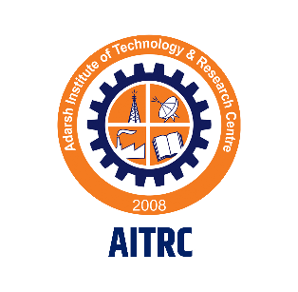
FIFTH SEMESTER
(Year: 2023-24)

Micro Project

Micro-Project Proposal
Environmental Studies [22447]
I

Micro-Project Proposal
Environmental Studies [22447]
I

Micro-Project Proposal
Environmental Studies [22447]
I

Micro-Project Proposal
Environmental Studies [22447]
I

Micro-Project Proposal
Environmental Studies [22447]
I

Micro-Project Proposal
Environmental Studies [22447]
I

Micro-Project Proposal
Environmental Studies [22447]
I

Micro-Project Proposal
Environmental Studies [22447]
I

Micro-Project Proposal
Environmental Studies [22447]
I

Micro-Project Proposal
Environmental Studies [22447]
I

Micro-Project Proposal
Environmental Studies [22447]
I

Micro-Project Proposal
Environmental Studies [22447]
I

Micro-Project Proposal
Environmental Studies [22447]
I

Micro-Project Proposal
Environmental Studies [22447]
I

Micro-Project Proposal
Environmental Studies [22447]
I

Micro-Project Proposal
Environmental Studies [22447]
I

Micro-Project Proposal
Environmental Studies [22447]
I

Micro-Project Proposal
Environmental Studies [22447]
I

Micro-Project Proposal
Environmental Studies [22447]
I

Micro-Project Proposal
Environmental Studies [22447]
I

Micro-Project Proposal
Environmental Studies [22447]
I

Micro-Project Proposal
Environmental Studies [22447]
I

Micro-Project Proposal
Environmental Studies [22447]
I

Micro-Project Proposal
Environmental Studies [22447]
I

Micro-Project Proposal
Environmental Studies [22447]
I

Micro-Project Proposal
Environmental Studies [22447]
I

Micro-Project Proposal
Environmental Studies [22447]
I

Operating System (22516)

Title of the Project: “Various Generations of Computer System and Operating system.”

Branch: Computer Technology (CM5I)
Members of the Group:
- Pratik Rahul Bamane Roll No. -3129
- Sanika Sunil Tirmare Roll No. -3130
- Mrudula Santaji Shinde Roll No. -3131
- Jahir Yasin Kulakrni Roll No.-3132

Loknete Hon. Hanmantrao Patil Charitable Trust’s
Adarsh Institute of Technology & Research Centre, Vita
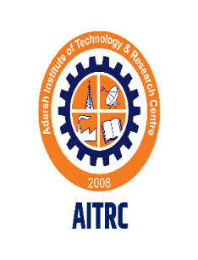
CERTIFICATE
This is to certify that the micro project report entitled

“Various Generations of Computer System and Operating system.”
Submitted by
Sr. No. | Name of Student | Roll No.
01 | Pratik Rahul Bamane | 3129
02 | Sanika Sunil Tirmare | 3130
03 | Mrudula Santaji Shinde | 3131
04 | Jahir Yasin Kulkarni | 3132

For Fifth Semester of Diploma in Computer Technology Of course Operating System (22516) for academic year 2023-24 as per MSBTE, Mumbai curriculum of ‘I’ scheme.

DIPLOMA OF ENGINEERING
(Computer Technology)

SUBMITTED TO
MAHARASHTRA STATE BOARD OF TECHNICAL EDUCATION MUMBAI
ACADEMIC YEAR 2023-24

Project Guide H.O.D. Principal
Prof.A.A.Vankudre Prof.A.A.Vankudre Dr. P.S.Patil

MAHARASHTRA STATE BOARD OF TECHNICAL EDUCATION, MUMBAI
MICRO PROJECT
Progress Report / Weekly Report

Title of the Project: “Various Generations of Computer System and Operating system”.
Course: OSY (22516) Program: Computer Technology (CM5I)
Week No | Date | Duration in Hrs. | Work / Activity Performed | Sign of the Faculty
1 |  | 2 Hours | Knowing the Basic
2 |  | 1 Hour | Decide Aim
3 |  | 2 Hours | Collect the Data
4 |  | 2 Hours | Prepare Project Proposal
5 |  | 1 Hour | Search Literature Review
6 |  | 1 Hour | Analysis of Data
7 |  | 1 Hour | Discussion over Preparing
8 |  | 2 Hours | Correction in Booklets
9 |  | 2 Hours | Report Writing
10 |  | 1 Hour | Checking Report
11 |  | 1 Hour | Correction report Write
12 |  | 1 Hour | Rechecking report
13 |  | 1 Hour | Finalizing report writing
14 |  | 1 Hour | Final Submission
15 |  | 1 Hour | Oral Presentation of Micro-Project

Teacher Evaluation Sheet for Micro Project

Course Title and Code: 22516

Title of the Project: “Various Generations of Computer System and Operating system.”
Group No: 08
COs addressed by the Micro Project:
CO 1:- | Install Operating System And Configure it.
CO 2:- | Use Operating System to perform various functions.

Marks: -
Roll No. | Name Of Student | Marks for Group Work (06) | Marks obtained by the individual based on viva (04) | Total Marks (10)
3129 | Pratik Rahul Bamane
3130 | Sanika Sunil Tirmare
3131 | Mrudula Santaji Shinde
3132 | Jahir Yasin Kulkarni

Name and designation of Faculty Member: Prof.A.A.Vankudre
Lecturer (Computer Technology Department)

Signature: _______________________

ACKNOWLEDGEMENT

I express my sincere gratitude to Prof.A.A.Vankudre Department of Computer Technology, for his stimulating guidance, continuous encouragement and supervision throughout the course of present work.

I would like to place on record my deep sense of gratitude to Prof.A.A.Vankudre HOD-Department of Computer Technology, for his generous guidance, help and useful suggestions.

I am extremely thankful to Principal Dr.P.S.Patil for this motivation and providing me infrastructural facilities to work in, without which this work would not have been possible.

I would like to express my gratitude to all my colleagues for their support, co-operation and faithful discussions on diverse seminar topics and technical help.

Name of Student | Sign
- Pratik Rahul Bamane
- Sanika Sunil Tirmare
- Mrudula Santaji Shinde
- Jahir Yasin Kulkarni

Index

Sr. No. | Content | Page No.
1.0 | Rationale
2.0 | Course Outcomes Addressed
3.0 | Literature Review
4.0 | Actual Methodology Followed
5.0 | Actual Resources Used
6.0 | Outputs of the Micro-Project
7.0 | Skill Developed / learning out of this Micro Project
8.0 | Applications of this Micro Project
9.0 | Area of Future Improvement

PART A- Micro Project Proposal

Title of Micro-:" Various Generations of Computer System and Operating system”.

1.0 Rationale:
The study of Operating system provides us with an understanding of human computer interface existing in computer system and the basic concepts and its working. The students will also get hand-on experience and good working knowledge to work in environments. The aim is to gain proficiency in using operating systems after undergoing this study. While doing so, we are known to the concepts and principles of operating systems, its features and practical utility.

2.0 Aim of the Micro-Project:

The primary goal of windows operating system is having convenience for the user. While the primary goal of is efficient operation of the computer system. The former Operating System exists because ,they are supposed to make it easier to compute them without them. This view is particularly clear when you look at Operating Systems for small PCs. The latter are used for large, shared, multi user systems. These systems are expensive, so it is desirable to make them as efficient as possible.

3.0 Intended Course Outcomes:

a) Install operating system and configure it.
b) Use operating system tools to perform various functions.
4.0 Literature Review:
- www.javapoint.com
- www.tutorialspoint.com
- www.guru99.com

- Proposed Methodology:

1.In this microproject, first of all we have focused on selection of appropriate topic for micro-project.
2. Select the topic i.e. Generations of Computer and Operating System.
3. Then we started with our brief study as well as a survey on our topic .
4. Then we gathered all information based on the topic of microproject.
5. We have done analysis and study of our topic in detail.
6. Following all the above methodologies we successfully completed with our microproject.

6.0 Action Plan:

Sr. No. | Details of activity | Planned Start date | Planned Finish date | Name of Responsible Team Members
1 | Project Proposal |  |  | All Members
2 | Data Collection & Analysis |  |  | All Members
3 | Preparation of Prototype /Model |  |  | All Members
4 | Preparation of Report |  |  | All Members
5 | Presentation and submission |  |  | All Members

PART B- Micro Project Proposal

- Intended Course Outcomes:
a) Install operating system and configure it.
b) Use operating system tools to perform various functions.
2.0 Literature Review:
- www.javapoint.com
- www.tutorialspoint.com
- www.guru99.com

3.0 Actual Methodology Followed

Name: All Members.
Member 1) Name: Pratik Rahul Bamane
Work: Search information regarding project subject.
Member 2) Name: Sanika Sunil Trimare
Work: Collect information and discuss with group members about proposal.
Member 3) Name: Jahir Yasin Kulkarni
Work: Analyze and finalize the information of the project report.
Member 4) Name: Jahir Yasin Kulkarni
Work: Write project report
Member 5) Name: Mrudula Santaji Shinde
Work: Prepare rough sketch and final chart

4.0 Actual Resources Used

Sr. No. | Name of Resource/material | Specifications | Quantity | Remarks
1 | Computer System | Laptop i5 8th gen, 8 GB Ram | 1
2 | Operating system | Windows 10 pro | 1
3 | Internet | Goggle Chrome | 1

5.0 Skill Developed/ learning out of this Micro-Project:

When CSS is used effectively, in terms of inheritance and "cascading", a global style sheet can be used to affect and style elements site-wide. If the situation arises that the styling of the elements should be changed or adjusted, these changes can be made by editing rules in the global style sheet. Before CSS, this sort of maintenance was more difficult, expensive, and time-consuming.

6.0 Future Scope:

The future of computer systems is promising, with rapid advancements in various domains. Staying informed about these trends and developments will be essential for anyone pursuing a career or research in computer science and related fields. Additionally, interdisciplinary knowledge in fields like biology, ethics, and sustainability will become increasingly valuable as computer systems continue to evolve.

7.0 Output of the Micro-project: -
- Computer system:
computer is a machine that can be instructed to carry out sequences of arithmetic or logical operations automatically via computer programming. Modern computers have the ability to follow generalized sets of operations, called programs These programs enable computers to perform an extremely wide range of tasks. A "complete" computer including the hardware, the operating system (main software), and peripheral equipment required and used for "full" operation can be referred to as a computer system. This term may as well be used for a group of computers that are connected and work together, in particular a computer network or computer cluster Computers are used as control system for a wide variety of industrial and consumer devices. This includes simple special purpose devices like microwave ovens and remote controls, factory devices such as industrial robots and computer-aided design and also general purpose devices like personal computers and mobile devices such as smart phones The Internet is run on computers and it connects hundreds of millions of other computers and their users. Early computers were only conceived as calculating devices. Since ancient times, simple manual devices like the abacus aided people in doing calculations. Early in the Industrial Revolution, some mechanical devices were built to automate long tedious tasks, such as guiding patterns for looms More sophisticated electrical machines did specialized analog calculations in the early 20th century.

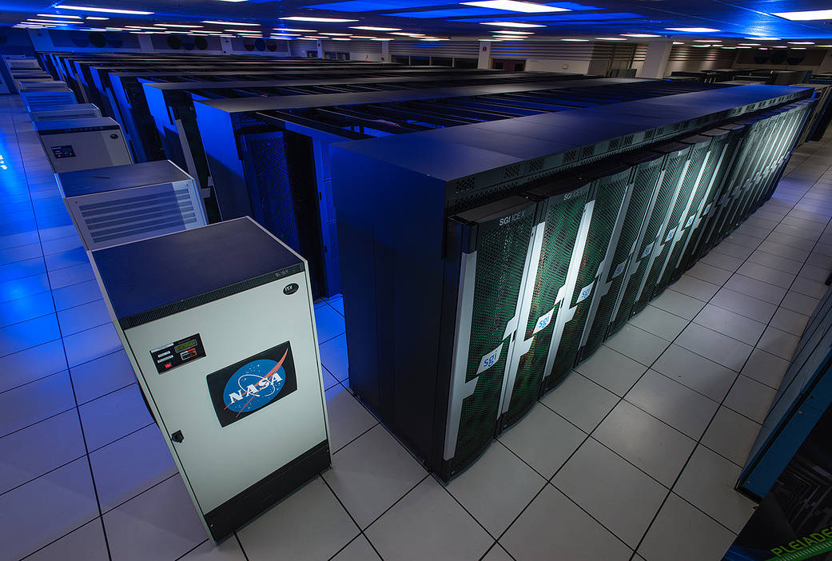

- Operating system:

The earliest computers were mainframes that lacked any form of operating system. Each user had sole use of the machine for a scheduled period of time and would arrive at the computer with program and data, often on punched paper cards and magnetic or paper tape. The program would be loaded into the machine, and the machine would be set to work until the program completed or crashed. Programs could generally be debugged via a control panel using dials, toggle switches and panel lights. Symbolic languages, assemblers and compilers were developed for programmers to translate symbolic program-code into machine code that previously would have been hand-encoded. Later machines came with libraries of support code on punched cards or magnetic tape, which would be linked to the user's program to assist in operations such as input and output. This was the genesis of the modern-day operating system; however, machines still ran a single job at a time. At Cambridge University in England the job queue was at one time a washing line from which tapes were hung with different colored clothes-pegs to indicate job-priority. As machines became more powerful the time to run programs diminished, and the time to hand off the equipment to the next user became large by comparison. Accounting for and paying for machine usage moved on from checking the wall clock to automatic logging by the computer. Run queues evolved from a literal queue of people at the door, to a heap of media on a jobs-waiting table, or batches of punch-cards stacked one on top of the other in the reader, until the machine itself was able to select and sequence which magnetic tape drives processed which tapes. Where program developers had originally had access to run their own jobs on the machine, they were supplanted by dedicated machine operators who looked after the machine and were less and less concerned with implementing tasks manually.

- Generations:

- The First Generation (1945 - 1955): Vacuum Tubes and plug boards:
Digital computers were not constructed until the second world war. Calculating engines with mechanical relays were built at that time. However, the mechanical relays were very slow and were later replaced with vacuum tubes. These machines were enormous but were still very slow.
These early computers were designed, built and maintained by a single group of people. Programming languages were unknown and there were no operating systems so all the programming was done in machine language. All the problems were simple numerical calculations.
By the 1950’s punch cards were introduced and this improved the computer system. Instead of using plug boards, programs were written on cards and read into the system.

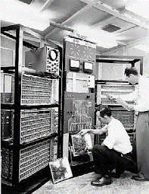

- The Second Generation ( 1955 - 1965 ): Transistors and Batch System:
Transistors led to the development of the computer systems that could be manufactured and sold to paying customers. These machines were known as mainframes and were locked in air-conditioned computer rooms with staff to operate them. The Batch System was introduced to reduce the wasted time in the computer. A tray full of jobs was collected in the input room and read into the magnetic tape. After that, the tape was rewound and mounted on a tape drive. Then the batch operating system was loaded in which read the first job from the tape and ran it. The output was written on the second tape. After the whole batch was done, the input and output tape

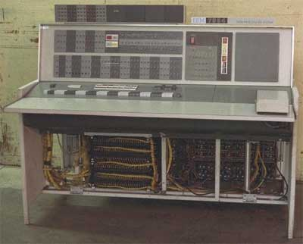

- The Third Generation (1965- 1980): Integrated Circuits and Multiprogramming:
Until the 1960’s, there were two types of computer systems i.e the scientific and the commercial computers. These were combined by IBM in the System/360. This used integrated circuits and provided a major price and performance advantage over the second generation systems. The third generation operating systems also introduced multiprogramming. This meant that the processor was not idle while a job was completing its I/O operation. Another job was scheduled on the processor so that its time would not be wasted.

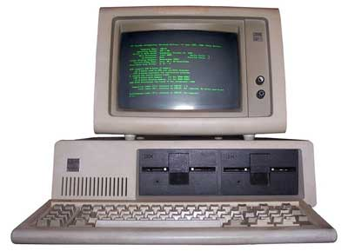

- The Fourth Generation (1980 - Present): Personal Computers
Personal Computers were easy to create with the development of large-scale integrated circuits. These were chips containing thousands of transistors on a square centimeter of silicon. Because of these,
microcomputers were much cheaper than minicomputers and that made it possible for a single individual to own one of them. The advent of personal computers also led to the growth of networks. This created network operating systems and distributed operating systems. The users were aware of a network while using a network operating system and could log in to remote machines and copy files from one machine to another.

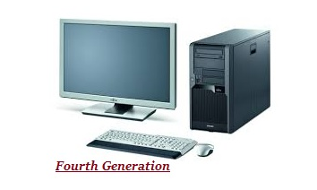
- The Fifth Generation Computers (present and beyond): Artificial Intelligence
In 1982, the fifth-generation computer system was begun by Japan's Ministry of International Trade and Industry. In this generation, the VLSI technology has advanced and become ULSI te
chnology, stands for Ultra Large-Scale Integration. That means ten million electronic components were used in the production of microprocessor chips.
sThe computer made in the fifth generation was created with the help of logic programming and massively parallel computing. This generation of computers was based upon parallel processing hardware and AI (Artificial Intelligence) software. Artificial intelligence has the ability to illustrates the means and method of making computers think the same as human beings. In this generation, all kinds of high-level languages such as C and C++, .Net, Java and more are used.
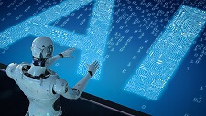

- Conclusion: -
As a result of the various improvement to the development of the computer we have seen
the computer begins used in all areas of life. It is a very useful tool that will continue to experience new development as time passes.

Computer are used in various areas of our life, Education, entertainment, sports, advertising, medicine, and engineering, government, office and home are some of application areas of the computers.

********************

